Nama : Bryant Sulthan Nugroho

NPM : 50423286

Kelas : 1IA03

Materi : PyQT5

Mata Praktikum : Algoritma Pemrograman 2B

|  |
| --- |
| from PyQt5.QtWidgets import *  from PyQt5.QtCore import *  from PyQt5.QtGui import QFont  *def* main():      global app, window, nama_textbox, npm_textbox, kelas_textbox      app = QApplication([])      window = QWidget()      window.setGeometry(400, 200, 400, 300)      window.setWindowTitle("Pertemuan 6 - 50423286")      layout = QVBoxLayout()      layout.setSpacing(10)      layout.setContentsMargins(20, 20, 20, 20)      label_judul = QLabel("Masukkan data diri Anda: ")      label_judul.setAlignment(Qt.AlignCenter)      label_judul.setFont(QFont("Arial", 16, QFont.Bold))      label_judul.setStyleSheet('color: #31363F')      label_nama = QLabel("Nama: ")      label_npm = QLabel("NPM: ")      label_kelas = QLabel("Kelas: ")      labels = [label_nama, label_npm, label_kelas]      for i in labels:          i.setFont(QFont("Arial", 12, QFont.Bold))          i.setStyleSheet('color: #31363F')      nama_textbox = QLineEdit()      npm_textbox = QLineEdit()      kelas_textbox = QLineEdit()      nama_textbox.setPlaceholderText("Masukkan nama, contoh: *Andi Budi")      npm_textbox.setPlaceholderText("Masukkan npm, contoh: *50xxxxx")      kelas_textbox.setPlaceholderText("Masukkan kelas, contoh: *1IA03 atau 1ia03")      textboxes = [nama_textbox, npm_textbox, kelas_textbox]      for tbox in textboxes:          tbox.setFont(QFont("Arial", 12, QFont.Bold))          tbox.setStyleSheet('padding: 5px; border: 1px solid #31363F; border-radius: 5px;')      button_input = QPushButton("Input Data")      button_input.setFont(QFont("Arial", 12, QFont.Bold))      button_input.setStyleSheet('color: #F5F7F8; background-color: #31363F; padding: 5px; border: 1px solid #31363F; border-radius: 5px;')      button_input.clicked.connect(on_clicked)      layout.addWidget(label_judul)      layout.addWidget(label_nama)      layout.addWidget(nama_textbox)      layout.addWidget(label_npm)      layout.addWidget(npm_textbox)      layout.addWidget(label_kelas)      layout.addWidget(kelas_textbox)      layout.addWidget(button_input, *alignment*=Qt.AlignCenter)      window.setLayout(layout)      window.show()      app.exec_()  *def* on_clicked():      if nama_textbox.text() and npm_textbox.text() and kelas_textbox.text():          message = QMessageBox()          message.setStyleSheet("background-color: #F5F7F8; color: #31363F")          message.information(window, "Data diri", "Nama: " + nama_textbox.text() + "\nNPM: " + npm_textbox.text() + "\nKelas: " + kelas_textbox.text().upper())          nama_textbox.setText("")          npm_textbox.setText("")          kelas_textbox.setText("")      else :          message = QMessageBox()          message.setStyleSheet("background-color: #F5F7F8; color: #AF0404")          message.warning(window, "Input Error", "Data tidak boleh kosong!")  if __name__ == '__main__':      main() |

Tampilan ketika semua form terisi

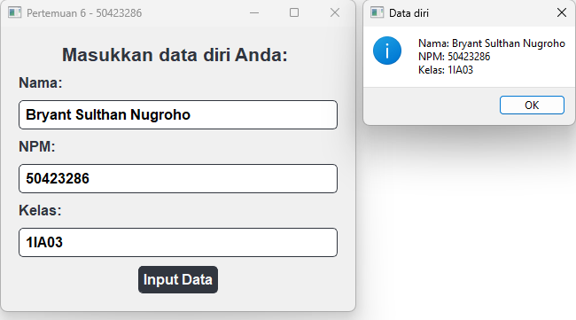

Tampilan ketika form kosong

